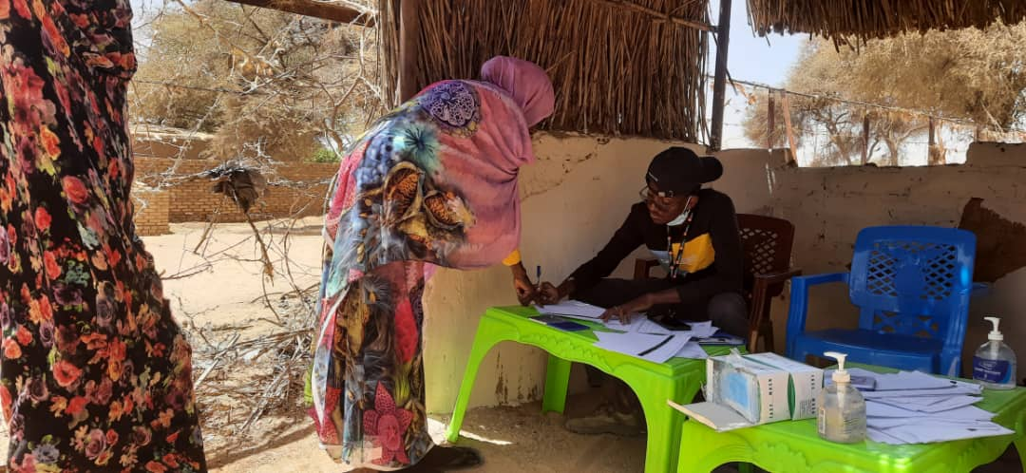
LEGAL IDENTITY & CIVIL DOCUMENTATION
STEPS FOR BIRTH, MARRIAGE AND DEATH REGISTRATION
The Norwegian Refugee Council (NRC) is an independent humanitarian organization helping people forced to flee. We work in crises across 31 countries, providing life-saving and long-term assistance to millions of people every year.
NRC works to protect the rights of displaced and vulnerable persons during crisis. In Sudan, NRC is implementing programmes under the Water sanitation and hygiene, Food security and Livelihoods, Education, Shelter and settlement, Camp coordination & camp management, Information counselling & Legal Assistance areas of competence.
Information, Counselling & Legal Assistance (ICLA) is a legal aid programme seeking to assist displaced persons to claim and fulfil their rights through application of information, counselling and legal assistance services.
In Sudan NRC ICLA conducts activities on Housing Land and Property (HLP) rights, legal identity and civil documentation and Employment laws and procedures.
THE NORWEGIAN REFUGEE COUNCIL
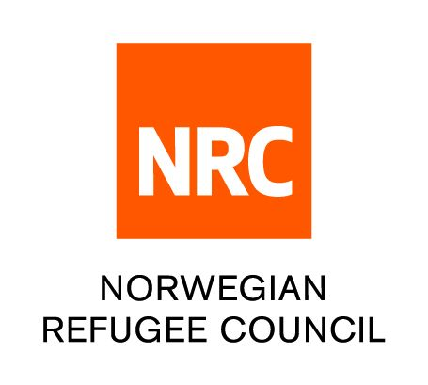
All information provided in this document is intended as a general guide only and is not a substitute for seeking advice from a qualified lawyer and/or government authorities. The information in this leaflet is subject to change and individuals should ensure that they obtain up to date information

INFORMATION SHEET ON

Steps of registration procedures: Birth, Marriage, Death

- BIRTH REGISTRATION
Birth registration is the process by which a child's birth is recorded in the civil register by the government authority. Once the birth has been registered, the child will be issued with a birth certificate.
Every new born child born in Sudan should be officially registered according the Law.

Documents required
- Report on the facts of the birth to be prepared and submitted by either the health institution where the birth took place or officials authorized by the civil registrar where the birth did not occur in the hospital
- Parent’s national numbers.
- Parents' Marriage certificate.

Procedure for registering births
- If the child is born in a hospital or health institution, the institution shall within 15 days from the date of birth send a copy of the birth report to the secretary of the civil registry.
- In a location where there are no regular medical services available the head of the civil registrar may authorize a person to receive the notification of births and deaths.
- If the birth did not occur in a hospital, a report of the birth should be made by following individuals to the official authorized by the civil registrar above to receive notifications of births and deaths in remote locations with no medical services;
- The physician who did the delivery
- The midwife who did the delivery
- The father who is present at the time of birth
- The mother where disease does not prevent her from reporting personally or in writing
- An adult person who resides with the mother in one home at the time of the birth
- The person in the house where the birth occurs
- The authorized official shall notify the secretary of the civil registry of birth facts within 30 days of the birth.
- The Secretary of the civil registry after receiving the report of the birth from the health institutions/ authorized officials shall register the birth facts.
- All births should be registered within one year of the occurrence. If the birth is registered within one year, the registration is free however if the birth is registered later than one year, a nominal fee of about 1700 SDG will be charged.
- Once you have obtained all the documents above, visit the civil registry office in your State.
- Once you enter you will find an officer sitting in the reception who will direct you to the window where you will be served.

Procedures for registering births;
- Once you have these documents, you will need go to the civil registry Or “Mobile civil registry units” – UNHCR organizes mobile visits by civil registry through-out the camps.
- Time allowed for birth registration is usually within 15–30 days of birth

  - MARRIAGE REGISTRATION
- Marriage registration is the process in which a marriage certificate is issued as an official statement to confirm that two people are married. There is a legal obligation to register all marriages.
- In Sudan marriage registration is governed by the Muslim Personal Law Act (1991)
- Although international law provides for a minimum age of 18 for marriage to occur, there is no minimum age of marriage in Sudan.
- Ministry of Justice and Traditional Courts are responsible for registering marriages and issuance of official marriage certificates. Church officials authorized to perform marriage ceremonies

Registering a Muslim marriage;
Documents required
- Form containing personal details of the applicant
- National identity card for husband and wife
- A document from Mazoon (Authorized person) to be submitted to the court;
- Fee of 5000 SDG

Procedure for registering marriages
- Formal Muslim marriages will be officiated by Mazoon who is authorized by the courts to register Muslim marriages. There is a Mazoon in each neighborhood.
- Once you obtain these documents approach the personal status court in your locality.
- Once you fill the form and pay the fee, you will be issued with a receipt.
- Submit the receipt to the officer in personal status court. In Dafur, there is a court complex in the following localities:
  - Al fasher - West of Naga Stadium and east of Al Fasher Cinema
  - In Kutum it is located in North of Ktum Market and west of Kutum Rural Hospital
  - Tawila - West of Tawila Market next to Police Station
- Marriage certificate will be processed between 2 – 4weeks

Registering a Christian Marriage
Documents required for IDPs
- Form containing personal details of the applicant
- National ID card for husband and wife
- Fee 5000 SDG for the stamps

Procedure for registering marriages
- Formal Christian marriage should be officiated in a church and the occurrence of the marriage registered in the marriage register in the church.
- Once you obtain these documents approach the personal status court in your locality. In Darfur, there is a court complex in the following localities:
  - Al fasher - West of Naga Stadium and east of Al Fasher Cinema
  - In Kutum it is located in North of Kutum Market and west of Kutum Rural Hospital
  - Tawila - West of Tawila Market next to Police Station

- Once you submit the form and pay the fee, you will be issued with a receipt. Submit the receipt to the officer in personal status court. Marriage certificate will be processed between 2 – 4weeks

  - DEATH REGISTRATION
- Death implies a person’s irreversible loss of life.
- This fact has an implication on the deceased family rights to succession and inheritance.
- Death registration implies the process by which one is officially pronounced as dead and hence a death certificate is issued after the civil registration of the occurrence of the death.
- There is an obligation to register all deaths
- A death certificate is required to obtain Burial permit, Certification that the death occurred from natural causes
- No fee is required for death registration

Documents required
- Notification from the hospital or authorized persons with the death incident report.
- Inheritance proclamation (it is a statement issued by the court of personal affairs in whose jurisdiction the person died).
- ID information of the deceased person.
- Kin’s identity document.
- Fees of 1700 SDG

Procedure for registering deaths
- If the death is in a hospital, then no witnesses are needed;
- The following individual are entrusted to report a death incident;
- The owner of the place in which death occurs, or the person in charge of its management, where that place is a factory, workshop, hotel, institute or any other place
- The parent of eth deceased person, or his sons, daughters, wife, brothers or sisters
- Any person of the adult relatives of the deceased who is present at the time of the death
- Any other adult person who resides with the deceased in the house where the death occurs
- The police officer within the local limits of whose jurisdiction the death has occurred.
- If the death occurs in a health institution or other health sectors, the institution should send a copy of the death report to the secretary of the civil registry within 7 days of the date of death.
- In a location where there are no regular medical services available the head of the civil registrar may authorize a person to receive the notification of births and deaths.
- If the death did not occur in a hospital, a report of the death should be made by the legal informants to the official authorized by the civil registrar above to receive notifications of births and deaths in remote locations with no medical services
- The authorized official shall notify the secretary of the civil registry of the death facts within 30 days of the death occurrence.
- The Secretary of the civil registry after receiving the report of the death from the health institutions/ authorized officials shall register the death facts.
Once you have obtained all the documents above, visit the civil registry office in your State
- Once you enter you will find an officer sitting in the reception who will direct you to the window where you will be served.

Requirements
- You need to report the incident of the lost document at the nearest police station located within your locality
- Fill the investigation form
- Take the notification from the police to the responsible authority;
- Death, Birth, ID = Civil Registry,
- Marriage Certificate= Personal Status Court
- Fill the request and submit it together with relevant documents
- You will be issued with a ticket to follow up

Locations of the civil registry in North Dafur State:
- El fasher - south of Alfasher Market next to Almozdawja primary School
- Kutum - West of Kutum Rural hospital

THE DIGITAL COMMUNITY HUB
- Call NRC for free on 015 655 9807
- Information available in English, Arabic, Tigrinya and Amharic (from 8:00 AM to 4:00 PM every day).
- If you are a Refugee or Internally Displaced Person in Khartoum, get information on obtaining legal documents and on our Cash for Food Programme.
- The call will not cost you anything.
- You can also leave us a message with your complaint or feedback on our services and we wll get back to you (Sunday - Thursday, between 8:00 AM and 4:00 PM)

www.nrc.no

